**ETL TESTING**

**Introduction** :

Launch the Source DB that is Microsoft SQL Server. Create a table insert values into the table using SQL Queries. Connect to Excel fetch data from Server and stored into Excel that is OLD using Macros codes execute the program click on Source DB button. Update values into the Server. Connect to Excel fetch data from Server and stored into Excel that is NEW using Macros codes run by click on Updated Values button. Compare OLD and NEW excel sheet values find differences stored into separate sheet that is Differences it’s execute the program click on the RUN button. Connect to Server fetch data from Excel and stored into Server that is Target DB using Macros codes execute the program by click on Target DB button. Every time open Run as Administrator.

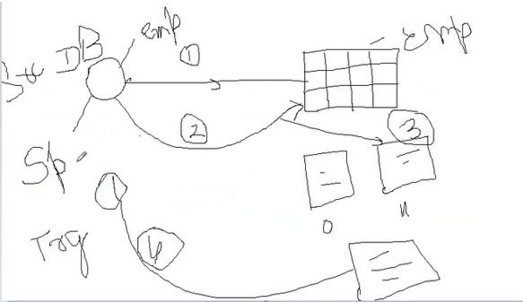

**Step 1:** Install Microsoft SQL Server

https://www.youtube.com/watch?v=C_KeaoJ6-Gc

<https://www.microsoft.com/en-in/sql-server/sql-server-downloads>

<https://learn.microsoft.com/en-us/sql/samples/adventureworks-install-configure?view=sql-server-ver16&tabs=ssms>

**Step 2:** Open SQL server. Create Table and Insert Values.

Create Table Emp

(

Emp_ID varchar(20),

Emp_Name varchar(25),

Salary Numeric,

Mob_Num Numeric,

);

Select * from emp;

insert into Emp values('Emp_01','Anand',10000,9080578851);

insert into Emp values('Emp_02','Kumar',14000,9080548851);

insert into Emp values('Emp_03','Gokul',12000,9080378851);

insert into Emp values('Emp_04','Rahul',18000,9080572851);

insert into Emp values('Emp_05','Saran',13000,9380572851);

insert into Emp values('Emp_06','Ramu',15000,9085572851);

insert into Emp values('Emp_07','Sekar',11000,9080972851);

**Step 3:** Open Excel check Developer Tab not present means

click on File🡪Options🡪Customize Ribbon 🡪Check Developer

**Step 4:** Click on Developer Tab. Click on VBA. Click on Insert 🡪 Module

Connect to Excel fetch data from Server and stored into Excel that is OLD using Macros codes execute the program click on Source DB button .

Sub Source_DB()

Dim cnt As ADODB.Connection

Dim rst As ADODB.Recordset

Dim Col_Max As Integer

Col_Max = ThisWorkbook.Sheets(1).UsedRange.Columns.Count

Dim sqlcmd As String

Dim sht As Worksheet

Set sht = ThisWorkbook.Sheets(1)

Set cnt = New ADODB.Connection

Set rst = New ADODB.Recordset

Dim server_name As String

Dim database_name As String

cnt.ConnectionString = "driver={SQL Server};server=SPBLRLTU627\SQLEXPRESS01;database=tempdb"

cnt.Open

With rst

.ActiveConnection = cnt

.Open "Select * From [tempdb].[dbo].[Emp]"

End With

Set sht = ThisWorkbook.Sheets.Add

sht.Name = "Old"

With sht

For Col = 0 To Col_Max + 1

.Cells(1, Col + 1).Value = rst.Fields(Col).Name

Next Col

Range("A2").CopyFromRecordset Data:=rst

End With

MsgBox "Connected"

End Sub

**Step 5:** Update values into the Server

Update Emp

Set Mob_Num = 9089578451

Where Emp_ID = 'Emp_01';

Update Emp

Set Salary = 21000

Where Emp_ID = 'Emp_02';

Update Emp

Set Emp_ID = 'Emp_10'

Where Emp_ID = 'Emp_03';

Update Emp

Set Emp_Name = 'Karan'

Where Emp_ID = 'Emp_04';

Update Emp

Set Mob_Num = 9089278451

Where Emp_ID = 'Emp_05';

Update Emp

Set Emp_Name = 'Aravind'

Where Emp_ID = 'Emp_06';

Update Emp

Set Salary = 19000

Where Emp_ID = 'Emp_07';

**Step 6:** Connect to Excel fetch data from Server and stored into Excel that is NEW using Macros codes run by click on Updated Values button

Sub Updated_DB()

Dim cnt As ADODB.Connection

Dim rst As ADODB.Recordset

Dim Col_Max As Integer

Col_Max = ThisWorkbook.Sheets(1).UsedRange.Columns.Count

Dim sqlcmd As String

Dim sht As Worksheet

Set sht = ThisWorkbook.Sheets(1)

Set cnt = New ADODB.Connection

Set rst = New ADODB.Recordset

Dim server_name As String

Dim database_name As String

cnt.ConnectionString = "driver={SQL Server};server=SPBLRLTU627\SQLEXPRESS01;database=tempdb"

cnt.Open

With rst

.ActiveConnection = cnt

.Open "Select * From [tempdb].[dbo].[Emp]"

End With

Set sht = ThisWorkbook.Sheets.Add

sht.Name = "New"

With sht

For Col = 0 To Col_Max - 1

.Cells(1, Col + 1).Value = rst.Fields(Col).Name

Next Col

Range("A2").CopyFromRecordset Data:=rst

End With

MsgBox "Connected"

End Sub

**Step 7:** Compare OLD and NEW excel sheet values find differences stored into separate sheet that is Differences it’s execute the program click on the RUN button.

Sub Compare_Values()

'Define Fields

Dim Row As Integer

Dim Col As Integer

Dim oRow As Integer

Dim Row_Max As Integer

Dim Col_Max As Integer

Dim sh1 As Worksheet

Dim sh2 As Worksheet

Dim sh3 As Worksheet

'Sheets to be compared

Set sh1 = ThisWorkbook.Sheets(1)

Set sh2 = ThisWorkbook.Sheets(2)

Set sh3 = ThisWorkbook.Sheets(3)

'Max Rows

Row_Max = sh1.UsedRange.Rows.Count

Col_Max = sh1.UsedRange.Columns.Count

'Read Data From Each Sheets of Both Excel Files & Compare Data

For Row = 1 To Row_Max

For Col = 1 To Col_Max

'Compare Data From Excel Sheets & Highlight the Mismatches

If sh1.Cells(Row, Col) <> sh2.Cells(Row, Col) Then

sh1.Cells(Row, Col).Interior.Color = vbGreen

sh2.Cells(Row, Col).Interior.Color = vbYellow

'Write Differences to Output sheet

oRow = oRow + 1

sh3.Cells(oRow, 1) = sh1.Cells(Row, Col)

sh3.Cells(oRow, 2) = sh2.Cells(Row, Col)

End If

Next Col

Next Row

'Process Completed

MsgBox "Executed Successfully"

End Sub

**Step 8:** Connect to Server fetch data from Excel and stored into Server that is Target DB using Macros codes execute the program by click on Target DB button.

Sub DbConnections()

Dim cnt As ADODB.Connection

Dim rst As ADODB.Recordset

Row_Max = Sheets("New").UsedRange.Rows.Count

Dim sqlcmd As String

Dim sht As Worksheet

Set sht = ThisWorkbook.Sheets("New")

Set cnt = New ADODB.Connection

Set rst = New ADODB.Recordset

Dim server_name As String

Dim database_name As String

cnt.ConnectionString = "driver={SQL Server};server=SPBLRLTU627\SQLEXPRESS01;database=tempdb"

cnt.Open

sqlcmd = "Create Table Target(Emp_ID varchar(20),Emp_Name varchar(25),Salary Numeric,Mob_Num Numeric)"

cnt.Execute (sqlcmd)

For I = 2 To Row_Max

sqlcmd = "INSERT INTO Target(Emp_ID,Emp_Name,Salary,Mob_Num)Values('" & sht.Cells(I, 1) & "','" & sht.Cells(I, 2) & "','" & sht.Cells(I, 3) & "','" & sht.Cells(I, 4) & "')"

cnt.Execute (sqlcmd)

Next

End Sub

**Step 9:** Createforms try to implement like an Application Design like this.

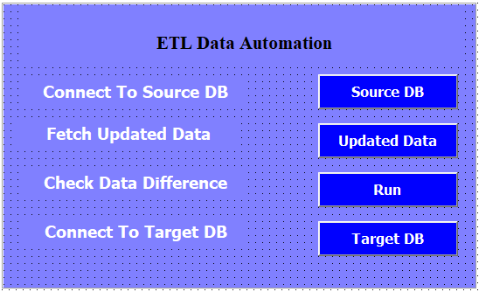

**Step 10:** Every Time Excel and SQL Server Open with Run as Administrator